
AI-Powered Legal Document Generator
Phase 05:
Project Development

AI-generated template, not legal advice; have a lawyer review.

Table of Contents
1. Environment Setup 2
2. Project Structure 2
3. AI Integration 2
4. API Implementation 3
5. Frontend 4
6. Challenges and Solutions 4

1. Environment Setup
python -m venv venv
source venv/bin/activate # Windows: venv\Scripts\activate
pip install -r requirements.txt
cp .env.example .env # Windows: copy .env.example .env
# optional: add GEMINI_API_KEY=... to .env (empty key = Demo mode)
uvicorn legalEaseAPI.main:app --host 0.0.0.0 --port 8000 # terminal 1
streamlit run frontend/app.py --server.port 8501 # terminal 2
# or start both at once: ./run.sh (Windows: run.bat)
python -m pytest -v # run the test suite

2. Project Structure
Table 1: Project files and their purpose
File or folder | Purpose
config.py | Central settings: .env loading, GEMINI_MODEL, limits, disclaimer, Demo-mode detection
ai_core/prompts.py | SYSTEM_INSTRUCTION, PROMPT_TEMPLATE and build_prompt()
ai_core/gemini_generator.py | GeminiDocumentGenerator: live call, output validation, error classes, fallback
ai_core/offline_generator.py | Deterministic templates (NDA, lease, employment, service, general)
ai_core/document_parser.py | split_terms, parse_parties, parse_document (text to blocks)
ai_core/generator.py | sanitize_text, HTML preview, TXT / DOCX / PDF exports, logo checks
legalEaseAPI/main.py | FastAPI app, GET / and GET /health, friendly 422 and 500 handlers
legalEaseAPI/routes.py | POST /generate with DocumentRequest and DocumentResponse models
frontend/app.py | Streamlit page: badge, form, preview, editor, downloads
frontend/api_client.py | Backend HTTP calls with friendly connection, timeout and 422 messages
frontend/helpers.py | validate_inputs, current_export_text, sample scenarios
.streamlit/config.toml | Dark theme with gold primary colour, headless server
Image/, assets/fonts/ | Own LegalEase logo (Pillow) and DejaVu fonts for Unicode PDFs
.env.example, .env | Configuration template with an empty key; local secrets (git-ignored)
run.sh, run.bat | Start backend and frontend with one command
tests/ (7 test modules) | pytest suite: 97 test cases from 63 test functions
scripts/ | Logo, screenshots, UI checks, videos, diagrams and document builders
docs/, media/ | Screenshots, evidence logs, demo and testing videos

3. AI Integration
GeminiDocumentGenerator creates one genai.Client with a timeout and a single retry attempt, then calls models.generate_content with the system instruction and generation settings from .env. The reply is sanitised and validated; any exception is classified and answered with an offline template.
def _get_client(self) -> Any:
if self._client is None:
from google import genai
from google.genai import types
self._client = genai.Client(
api_key=self.settings.gemini_api_key,
http_options=types.HttpOptions(
timeout=int(self.settings.gemini_timeout_seconds * 1000), # milliseconds
retry_options=types.HttpRetryOptions(attempts=1), # fail fast, we have a fallback
),
)
return self._client
def _call_gemini(self, prompt: str) -> str:
from google.genai import types
response = self._get_client().models.generate_content(
model=self.settings.gemini_model,
contents=prompt,
config=types.GenerateContentConfig(
system_instruction=SYSTEM_INSTRUCTION,
temperature=self.settings.gemini_temperature,
max_output_tokens=self.settings.gemini_max_output_tokens,
automatic_function_calling=types.AutomaticFunctionCallingConfig(disable=True),
),
)
text = getattr(response, "text", None)
return text or ""

4. API Implementation
@router.post("/generate", response_model=DocumentResponse, summary="Generate a legal document")
def generate_legal_document(request: DocumentRequest,
generator: GeminiDocumentGenerator = Depends(get_generator)) -> DocumentResponse:
"""Draft a structured legal document from the four inputs.
Never fails because of the AI provider: on any Gemini error the response has
``mode="fallback"`` and a human-readable ``notice``.
"""
result = generator.generate(request.document_type, request.parties, request.terms, request.dates)
return DocumentResponse(**result.to_dict(), terms=split_terms(request.terms))

Real request and response captured while building this document (Demo mode, document shortened):
POST /generate
{
"document_type": "Freelance Work Contract",
"parties": "Jane Doe (Service Provider), TechNova Inc. (Client)",
"terms": "Payment to be made within 30 days of invoice; The provider agrees to deliver work by the agreed deadline; Confidentiality must be maintained at all times; Either party may terminate with 15 days notice",
"dates": "October 1, 2026"
}
HTTP 200
{
"document": "FREELANCE WORK CONTRACT\n\nThis Freelance Work Contract (the \"Agreement\") is made and entered into as of October 1, 2026 (the \"Effective Date\") by and b ... (5388 characters)",
"mode": "demo",
"model": null,
"notice": "Demo mode: no Gemini API key is configured, so the deterministic offline template engine drafted this document.",
"error_type": null,
"elapsed_ms": 0,
"terms": [
"Payment to be made within 30 days of invoice",
"The provider agrees to deliver work by the agreed deadline",
"Confidentiality must be maintained at all times",
"Either party may terminate with 15 days notice"
],
"disclaimer": "AI-generated template, not legal advice; have a lawyer review."
}

5. Frontend
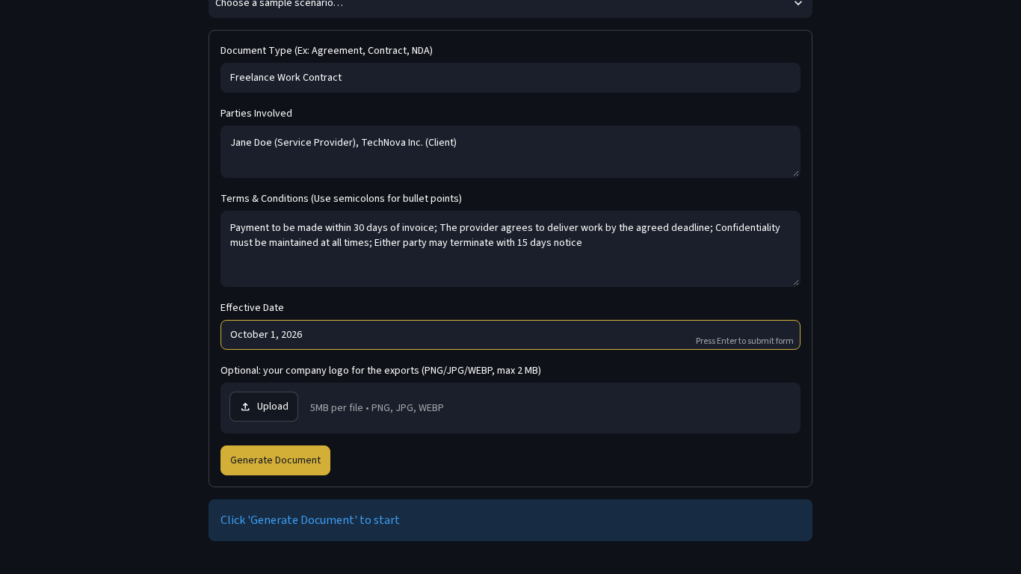 | 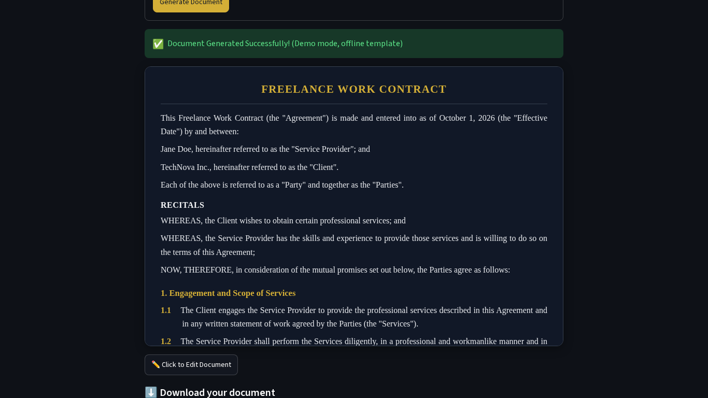
Figure 1: Form filled for Scenario 1 | Figure 2: Generated preview

The edit feature fixes a bug from the original brief: the downloads used the AI draft and ignored the user's edits. Now the preview and every download call the helper below.
def current_export_text(state: Mapping[str, Any]) -> str:
edited = state.get("edited_text") or ""
if edited.strip():
return edited
return state.get("generated_text") or ""

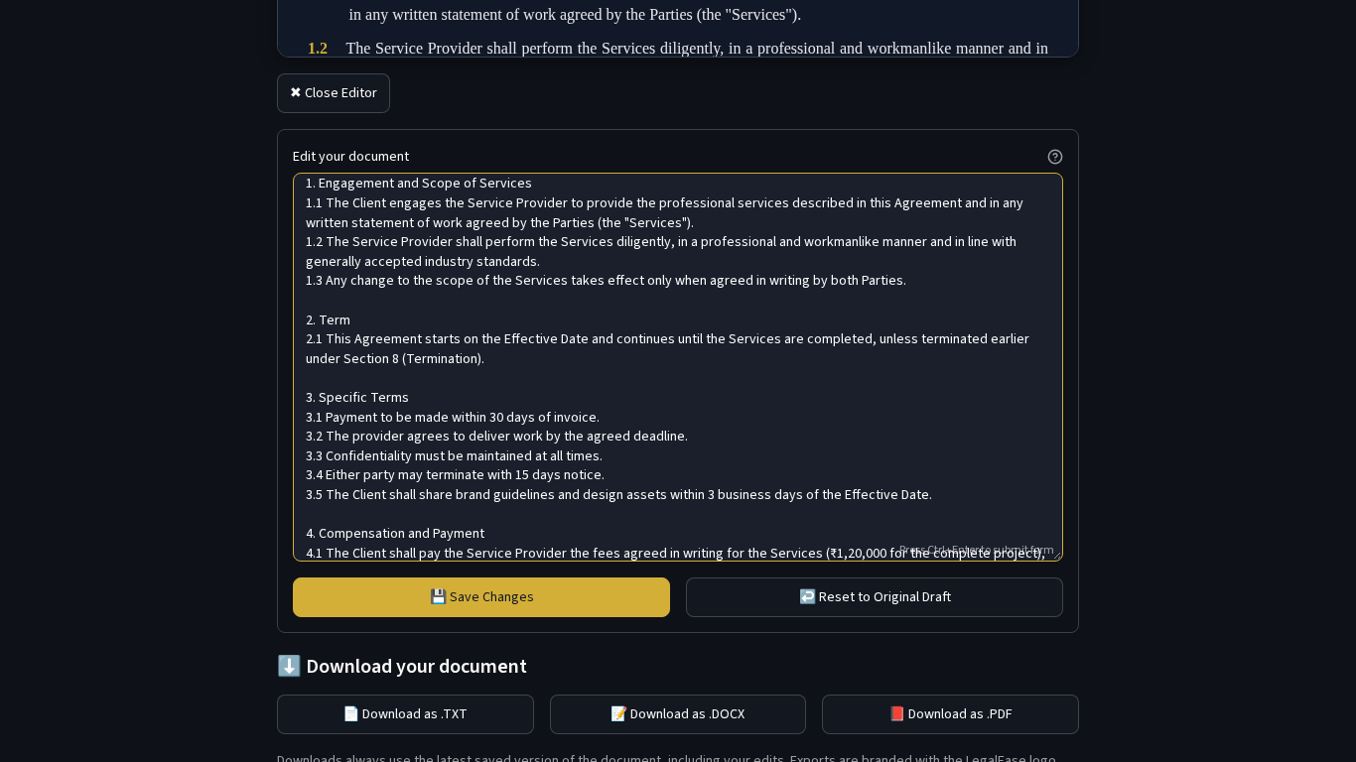 | 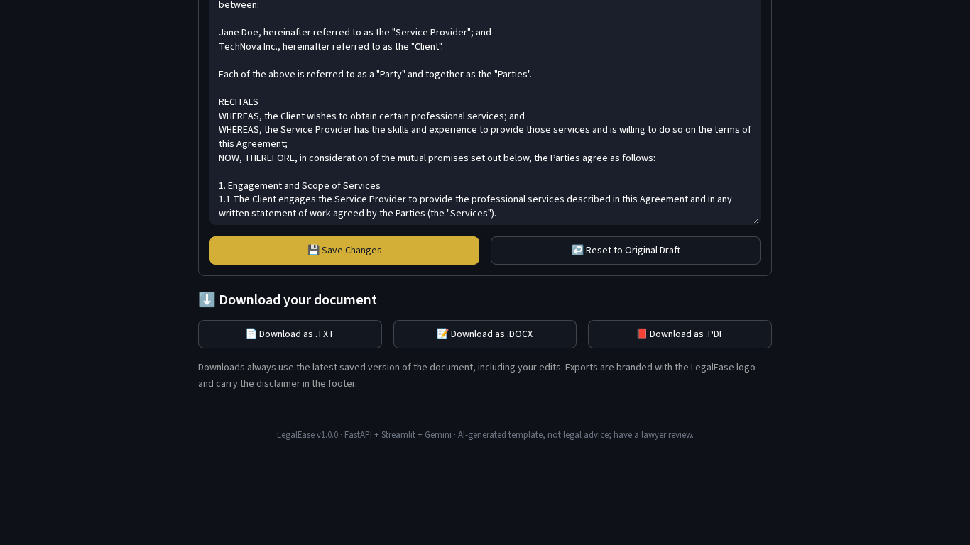
Figure 3: Editing the document | Figure 4: Download buttons

6. Challenges and Solutions
Table 2: Real challenges met during development
Challenge | Why it mattered | Solution
The spec used the old google-generativeai SDK (genai.configure) | The old SDK is deprecated and its examples no longer match the current API. | Rewrote the integration with the current google-genai SDK (genai.Client, models.generate_content, HttpOptions for timeout and retries).
The spec hard-coded gemini-1.5-pro | Gemini 1.5 models are retired and 2.5 models are being shut down for new projects. | The model ID is read from GEMINI_MODEL in .env (default gemini-3.8-flash), so it can change without code edits.
Downloads in the spec used generated_text | User edits were silently lost in every downloaded file. | Added current_export_text(): the preview and all three downloads use the latest saved edit; covered by tests and UI checks.
No real API key was available during development | The live success path could not be demonstrated end to end. | Built Demo mode and a fallback path; tested live-mode logic with a fake Gemini client and exercised a real Google error with a deliberately invalid key.
Unicode in PDF export | The classic fpdf library cannot print the rupee sign or curly quotes. | Switched to fpdf2 with bundled DejaVu Serif/Sans fonts; missing glyphs (e.g. Tamil) log a warning instead of crashing.
User text containing { } broke template filling | Python str.format() raised errors for terms such as {amount}. | Replaced str.format() with a small regex-based _fill() that only replaces known placeholders.
Automating Streamlit for screenshots | The quick-fill selectbox closes when the page scrolls, and Streamlit scrolls inside an inner container. | Wrote Playwright helpers that scroll the element first, retry the selection and offset the fixed header.

